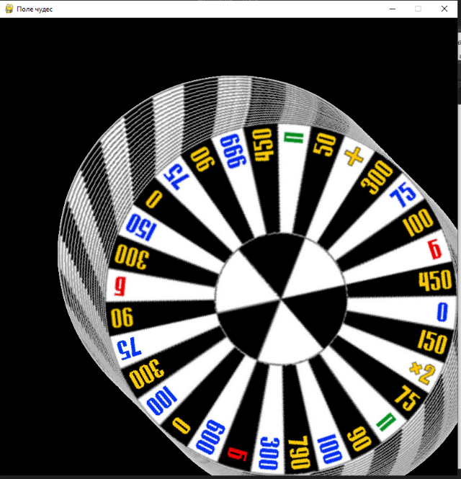Поле чудес

from pygame import *  
  
size = W, H = 800, 800  
FPS = 50  
OK = 1  
S = display.set_mode(size)  
display.set_caption('Поле чудес')  
clock = time.Clock()  
baraban = image.load('wheel.png')  
*# S.blit(baraban, (100,100))  
# display.flip()*x = 0  
  
while OK:  
 for e in event.get():  
 if e.type == KEYUP and e.key == K_ESCAPE or e.type == QUIT:  
 OK = 0  
 image = transform.rotate(baraban, x)  
 S.blit(image, (100, 100))  
 *# display.update() # Обновляет часть отображения интерфейса* display.flip()  
 *# S.fill('black')* clock.tick(FPS)  
 x += 1

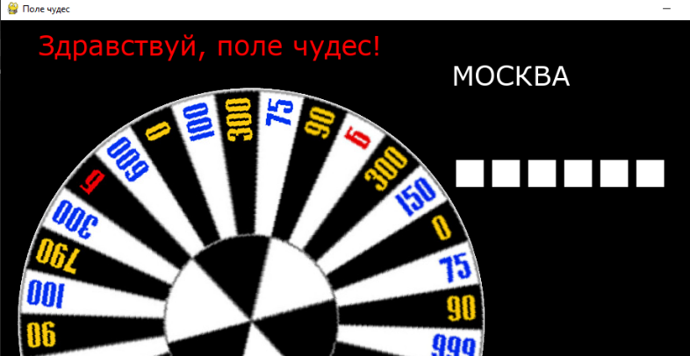

from pygame import *  
from random import *  
font.init()  
  
size = W, H = 1000, 800  
FPS = 50  
OK = 1  
S = display.set_mode(size)  
display.set_caption('Поле чудес')  
clock = time.Clock()  
  
display.flip()  
a, da = 0, 5  
x, y = W / 3, H / 2  
baraban = image.load('wheel.png')  
  
text = 'Здравствуй, поле чудес!'  
f1 = font.SysFont('Verdana', 36)  
f2 = font.SysFont('serif', 80)  
words = ['МОСКВА', 'ПИТЕР', 'КОСТРОМА']  
rand_word = choice (words)  
base_word = '■' * len(rand_word)  
  
render_text = f1.render(text, True, 'red')  
render_word = f2.render(rand_word, True, 'white')  
render_base = f2.render(base_word, True, 'white')  
S.blit(render_text, (50, 10))  
S.blit(render_word, (600, 50))  
S.blit(render_base, (600, 150))  
  
  
  
  
def rotate():  
 image = transform.rotate(baraban, a)  
 new_rect = image.get_rect(center=image.get_rect(center=(x, y)).center)  
 S.blit(image, new_rect)  
  
  
while OK:  
 for e in event.get():  
 if e.type == KEYUP and e.key == K_ESCAPE or e.type == QUIT:  
 OK = 0  
  
 *# display.update() # Обновляет часть отображения интерфейса* display.flip()  
 *# S.fill('black')* clock.tick(FPS)  
 a += da  
 da -= 0.05  
 if a >= 0:  
 rotate()  
 else:  
 da = 0